**EXERCICES ON FUNCTIONS**

1. Open the **exercise folder** on VSCode
2. For **each functions to implement** (see below table) :

* Define the function and the body
* Print on console to test the function
* Run the index.html and check the console log

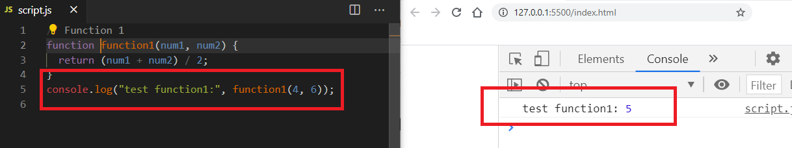

|  |  |  |
| --- | --- | --- |
| **Function name** | **Arguments** | **Return** |
| function1 | n1 : **number**  n2 : **number** | The average  Example:  n1 = 14 n2 = 16  return = 15 |
| Function2 | s1 : **string**  s2 : **string** | The merge  Example:  n1 = ‘ronan” n2 = “ the best”  return = “ronan the best” |
| Function3 | numbers: **array** of **numbers** | True if all equal  Example:  numbers = [4, 4, 4, 4]  return = true |
| Function4 | student = { name : s1, age : n1} : **object** | A string  Example:  student = { name : ‘ronan’, age : 17}  return= ‘student ronan is 17 year old’ |
| Function5 | s1 : **string**  s2 : **string** | True if s1 is longer than s2  Example  s1 = “aaa”  s2 = “a”  return = true |
| Function6 | numbers: **array** of **numbers** | Sum of all elements |
| Function7 | **row** : number  **column**: number | An array of **row** rows and column **columns** full of 0  Example  Row = 2  Column = 3  Return = [ [0, 0, 0], [0, 0, 0] ] |
| Function8 | array1: **array** of **numbers**  array2 : **array** of **numbers** | The array of the sum of each element from array1 and array2  Example  Array1 = [1, 2, 3]  Array2 = [4, 4, 4]  return = [5, 6, 7] |